# Genotype Calling Workflow

There are two stages to call genotype automatically as below picture. PGx team involve in steps in Red color.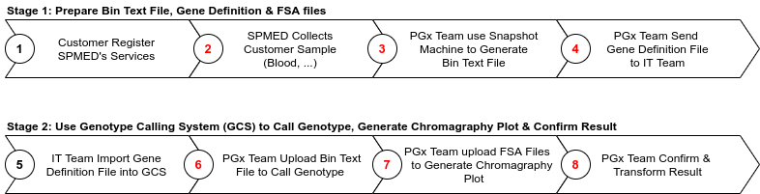

# Genotype Calling Feature Introduction

To use Genotype Calling System (GCS), you should go to <https://gc.spmed.kr/genotype> website. There are three features in GCS: (a) Genotype Management, (b) Bin Text File Management, and (c) Transform Management.

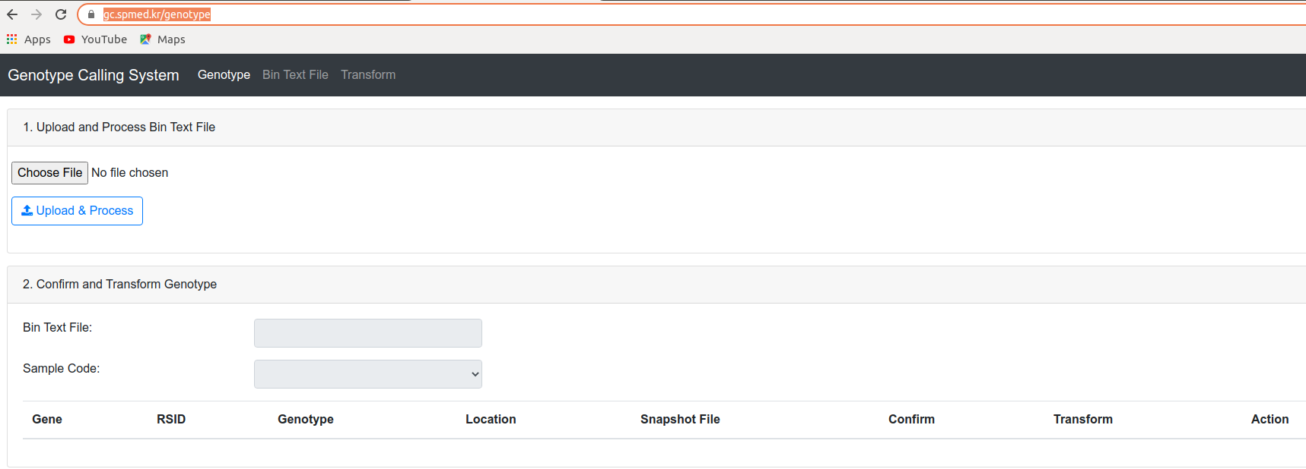

Figure 1. Genotype calling system website

1. Genotype Management: this is main feature of Genotype Calling System. Some use cases to use this feature are:

* Call genotype (Step 6 in Stage 2): use Bin Text File that prepared in Step 3 to “Upload & Process”
* View genotype information of uploaded Bin Text File
* Edit genotype information before confirming (note that genes that is confirmed cannot be edited)
* View history of genotype modification
* Confirm & Transform Result (Step 8 in Stage 2): see how to confirm & transform below

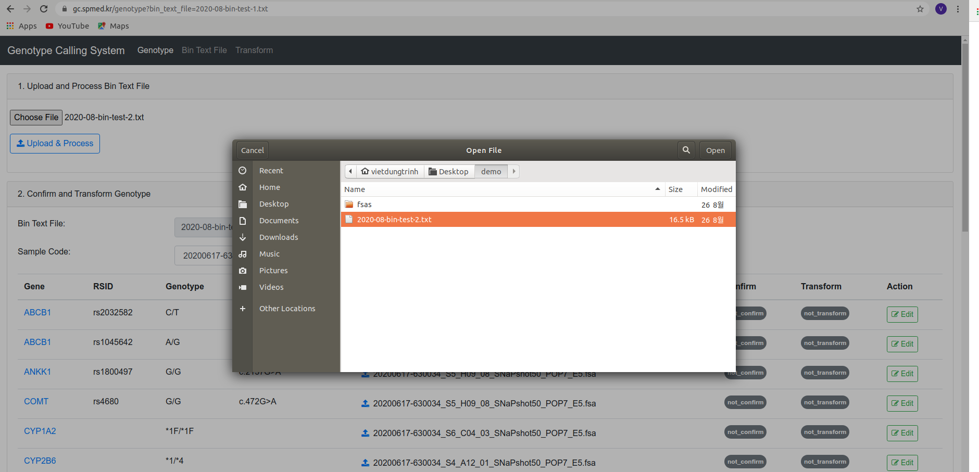

Figure 2. Uploading exported bin file for calling genotypes

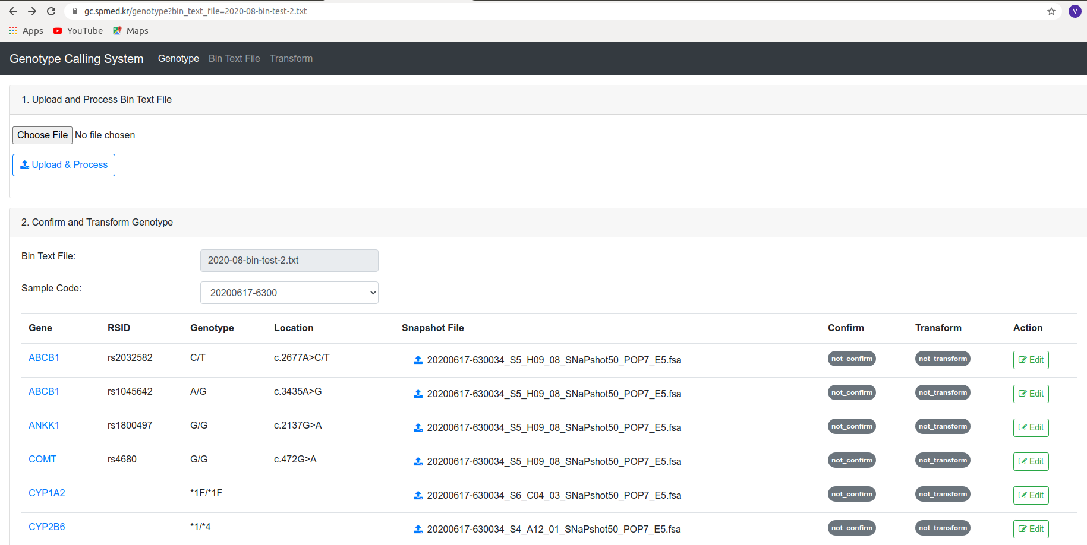

Figure 3. Genotyping results

Click “Edit” to update information and view modification history.

Click “Upload Icon” in Snapshot File column to generate chromagraphy plot. After generating plot, FSA file will be linked to this plot.

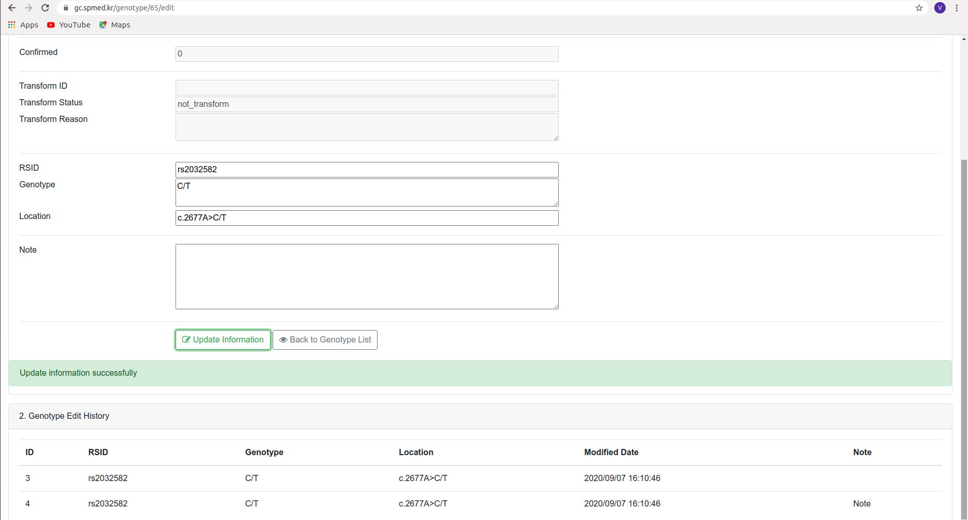

Figure 4. Editing genotyping results and viewing history were developed

1. Bin Text File Management

* View list of uploaded Bin Text Files
* View details information of Bin Text File: include sample list, FSA file list, and chromagraphy plots
* Generate Chromagraphy plot based on FSA file.

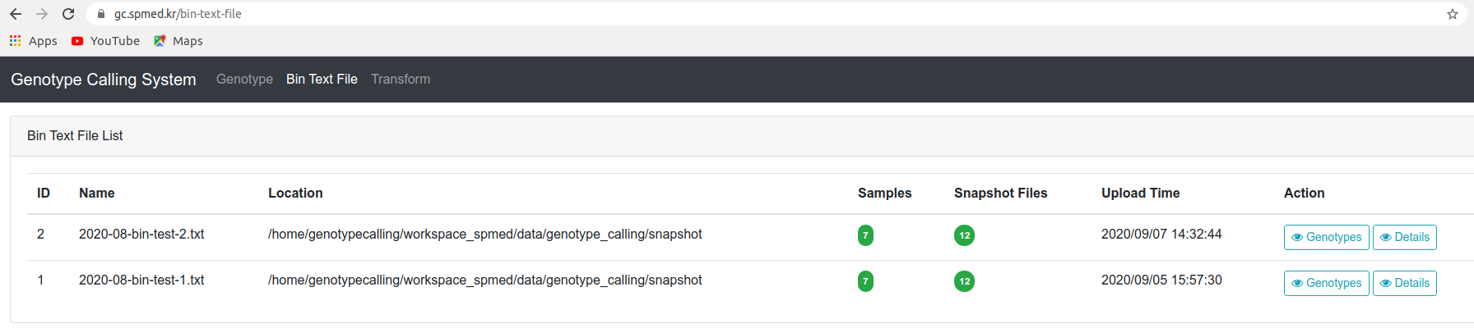

Figure 5. List of processed bin text files

Click “Genotypes” to view genotype list

Click “Details” to view details information and generate chromagraphy plot

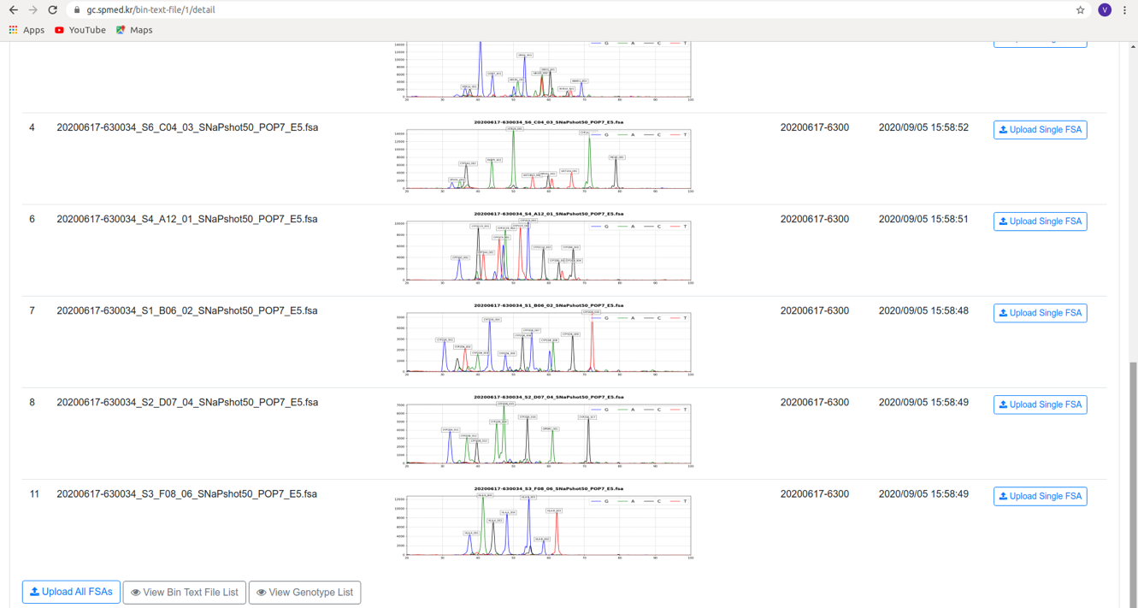

Figure 6. Chromatogram generation if FSA file was uploaded

Click “Upload Single FSA” to generate single plot

Click “Upload All FSAs” to generate multiple plots

After chromagraphy plot is generated, link to this file will automatically be created in genotype list

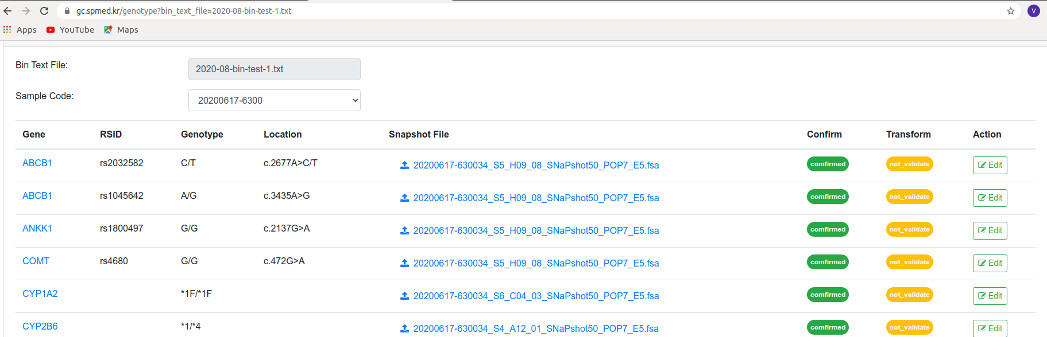

Figure 7. Hyperlink of FSA file and chromatogram plot

1. Transform Management

* View list of transformed Bin Text Files
* View details information of transformed Bin Text File like time to transform, status.

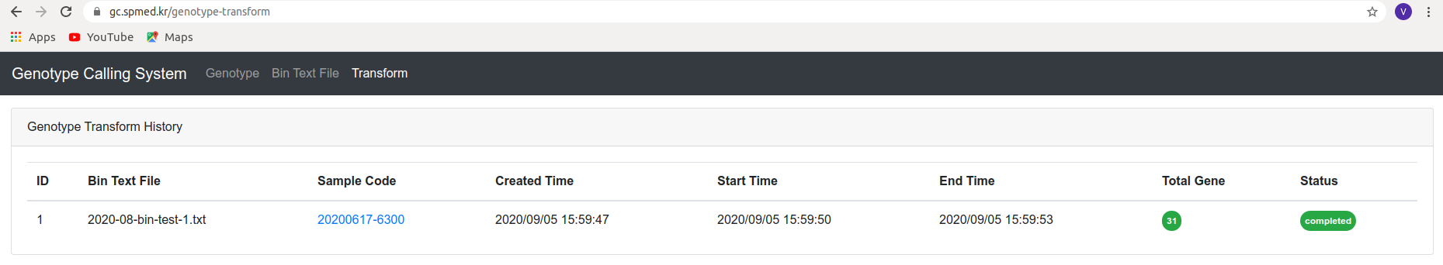

Figure 8. Transformation was recorded

**How to confirm the result**:

* Confirm means that we validated information, all information is correct and ready to use.
* There are two self-explained statuses: ***not_confirm*** and ***confirmed***.
* It is mandatory to confirm result before transforming result to other systems for usage.
* Current version of GCS supports to confirm the result sample by sample. It means that we cannot confirm single genotype, but all genotypes of single sample. Before confirming the result, PGx team need validate the result by showing chromagraphy plots. If the chromagraphy plots are not ready to show, upload FSA files to generate the chromagraphy plots. If have any incorrect information, use Edit feature to update information.

**How to transform the result:**

* Transform means that we link the result of GCS to other systems by moving this result from GCS to other systems. So other system can use this result of GCS to do their jobs (for example: to generate report)
* There are five self-explained transform statuses of genotype: ***not_transform***, ***transforming***, ***completed***, ***fail***, and ***not_validate****.* In case the status is fail or not_validate, additional information will be provided (like reason for fail) to easily resolve problem.
* Current version of GCS supports to transform the result sample by sample. It means that we cannot transform single genotype, but all genotypes of single sample.
* Note: There are differences between transform-status of genotype and transform status of sample. Transform status of sample have four possible values: ***not_transform***, ***transforming***, ***completed***, and ***fail***.

# **Genotype Calling Test Scenarios**

This section presents how to verify if the Genotype Calling System runs correctly or not. To verify the system, we are going to do some tests following by below test scenarios.

There are four components needed for testing the genotype calling results.

* Genotype calling result table (view from our genotype portal)
* Definition tables (excel file)
* Chromatogram plot
* Bin text file that was exported from the SNAPshot machine

Checking process

* Step 1. Check the called genotype from the result or bin text file with the chromatogram plot for making sure that no out-of-range marker. This step is critically important because it directly affects to genotype calling results.
* Step 2. Check QC status that was composed of 4 criteria below (Figure 9).
  + Allele status: False if called allele of each marker not in the definition table
  + Is a valid marker: check if a marker whether in definition tables or not, if not return False
  + Is valid genotype: check if any ‘blank’ genotype (no call allele in the bin text file), if blank genotype, return false
  + Is genotype called: check if the genotype was called or not. Please note that in the case of a gene without star-allele, if the genotype is not valid, this criterion is also False.

If QC is Pass that means 4 criteria are TRUE, otherwise, FALSE

Note: QC status is only from the programming checking approach, you may need to review carefully before confirming.

* Step 3. Check the called star allele (apply for a gene with star-allele).
* Step 4. Confirm or edit the genotype if you found any incorrect and note the reason why you change or where this error comes from. This is very useful for us to improve the system in the future.

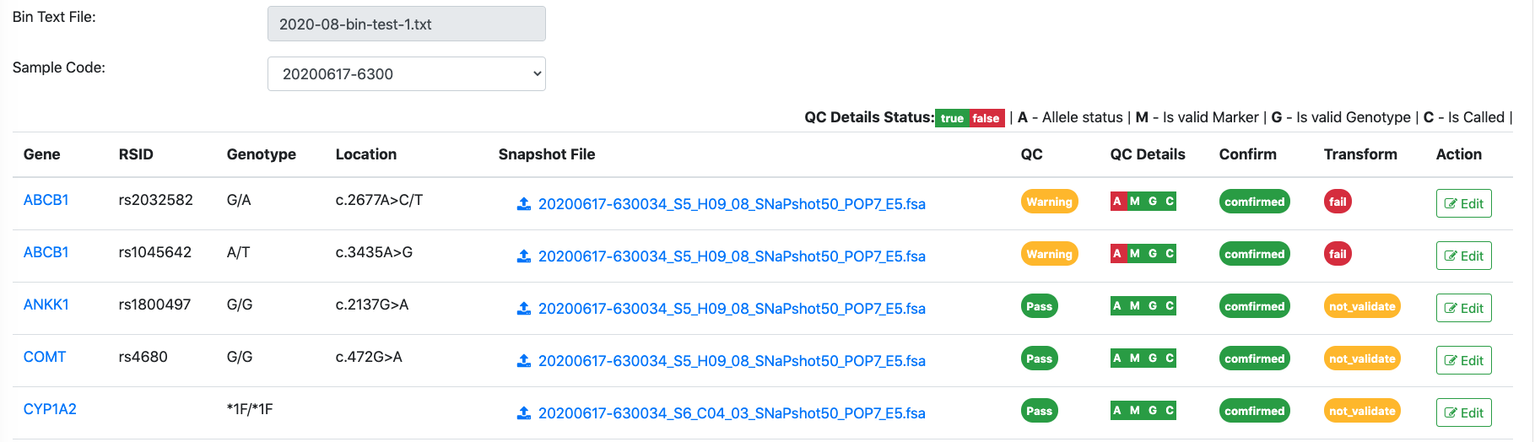

Figure 9. Programmatical quality control was shown as QC status.